GW ER Orientation
Welcome to the ER! We want you to have a great experience treating a range of pathology while experiencing the complexities of an urban emergency department. The following orientation guide is to get you started, but please ask our residents, staff, or attendings any time you need help! We always welcome feedback and concerns at ​2018gwemchiefs@gmail.comor anonymously at​ ​www.traumayellow.com​. We take issues very seriously and are always working to improve our department.

The ER
Our ER has a confusing numbering system. The “Critical Care” beds, designated CC1-CC4, are for the most critical patients. CC3 is for traumas. These rooms have airway and code carts. The main ER beds are designated “M1-M25” and the hallway beds are “MH1-MH7”. The urgent care beds are “UC1-UC12” on the fast track side of the department; this is also where UC1 or the ‘eye room’ with slit lamp and other ENT goodies are kept.
Where do I put my stuff?
You can place your bags, food, and coats in the staff lounge just past the trauma bay. There are staff restrooms near the staff lounge as well as near M9 behind the nursing station. ER Residents should have access to the “on call” room next to the ER Conference room, where they can also store their items (need a key for entry).

Signout & Starting Your Shift
What are teaching shifts?
Your first shifts you will be paired with an upper level EM resident to help orient you to the department and how to use FirstNet. By the end of these shifts, you should feel confident running the service by yourself, so make sure you understand the processes of consults, admissions, discharges, etc. Many of our residents have great tips for efficiency, so if you are feeling comfortable with the basics, try to pick up some of their advice. We also have videos explaining ​how to use smartphrases and macros​.
How does my shift start?
Plan on being ready to start 5 minutes before your scheduled time. Every shift starts with an attending supervised sign-out when you will inherit all of the patients on your team from the prior resident. Make sure you are comfortable with each patient in case they need to be admitted or require critical treatment. We recommend making a list of patients with a “to do” list for each patient. Once sign out is done, new patients are assigned to each team by the upper level resident. Once a patient is assigned to your team, you should see the patient as soon as possible.
There is a great ​sign-out aid called Safer Signout, which providers a template to assist with your​ signout and ensure good continuity of care. Consider using the Safer Signout tool for your first few signouts until you feel comfortable without it.
What is expected at signout?
Near the end of your shift (30 minutes), you should stop picking up new patients. Focus on disposition for as many patients as possible and clear list of duties for active patients for the oncoming resident. If a patient is ready to be admitted, you should admit them before leaving, instead of leaving this to the oncoming resident. If you anticipate discharge for a patient, tell the oncoming residents what is pending their disposition and have their discharge paperwork queued to go. Remember, you are the person who first evaluated the patient and have treated them thus far, so you know the most about the patient.
Procedures should not be signed out within reason. You are responsible for laceration repairs, lumbar punctures, vaginal exams, rectal exams, etc. Passing off procedures puts the new resident in a difficult and potentially unsafe situation, since they did not initially evaluate the patient and there is a potential for a wrong-patient or wrong-procedure mistake to occur.
Giving Sign Out
- Run your list with your attending/senior prior to signout, bc this will highlight whatever issues you have and help with...
- Disposition. Every patient you sign out should have a plan of care, either they are already dispositioned (admitted or discharged) or you have provided a plan of care.
- If the patient is admitted, lead your presentation with the diagnosis “This is Ms. Smith, she’s a 40 y/o female admitted for cholecystitis….”
- If the patient is ‘active’ you should provide your differential and a plan; “This is Ms. Smith, she’s a 40 y/o female who might have biliary disease. She’s here with 2 days of belly pain and
nausea. Her ultrasound is pending, and her labs show a mild leukocytosis. If the ultrasound is negative… If the ultrasound is positive…”
- Finish your charts. If your patient is eventually going home, you should precomplete their discharge paperwork and prescriptions if the diagnosis is known. For example, a headache patient who is being treated, but will probably then be discharged should have their discharge paperwork completed before you leave.
- Run the list again! Once you are done signing out, have the on-coming resident run through the entire list to make sure you are both on the same page.
Receiving Sign Out
- Look at labs and VS for the patient. The offgoing resident may not have had a chance to review recent results/imaging as he/she is tying up the service so this is a great time to follow up on works ups. Note any abnormal VS or lab values and ask about baseline Cr, anemias, strange CT findings, etc.
- Ask the offgoing teams to remember to check their charts for completeness before leaving.
- Spend time doing your own reevaluation for anyone whose disposition is pending. People who tend to displode are people with abdominal pain, people who have not yet ambulated (they can’t go home if they can’t ambulate), people with difficult social situations, people with a lot of pain after trauma despite negative imaging, and people with AMS. Trust but verify the sign out, as situations can develop!
  - You need your own baseline when starting a shift. If you’re admitting a patient, you need your own exam. This is essential for neuro exams for AMS, abdominal exams, etc.
  - Try to walk patients signed out as ‘road test’, or if you cannot get to this, ask the nursing staff to do this for you and let you know how it went.
  - For stable people who are already admitted to teams you can quickly say hi or peek your head into their room.
  - If someone sounds like a tough dispo (elderly, psych, wheelchair bound), they probably will be. Make sure to get info about home situation, family contact information and how that person might get home
- Ask questions during sign out! It slows signout down a little, but ask clarifying questions for things you are confused about or whether parts of the workup are done or ordered
- Have a low threshold to add on new labs or x-rays early which seem to be lacking or if they will hold up a later decision (eg urine for abdominal pain, ESR/CRP for ortho infections, trop/EKG for possible ACS, coags for Liver patients/on warfarin).
- Be aware of the level and specialty of the person giving sign out.
- For patients without a dispo, look at the time the patient arrived. Notice how long have they been in the department without a dispo. There are two groups that are in need a thorough evaluation from you: those who have just arrived, and those who have been in the department for an entire shift (or more) without a dispo. Be seriously concerned about a signout to re-eval or MTF a patient who is a signout of a signout. Crossing two shifts without a dispo is a serious red flag.
  - Our psychiatric patients, especially the dual-diagnosis ones, are an especially vulnerable population. Speak with them yourself and do a basic physical exam once it is safe.

When do I present?
This is attending dependent, however during your first few weeks, you will typically present one or two patients at a time to the attending assigned to the patient. As you become more comfortable, you may find yourself checking-in with the attending less. There are some tests you should not order without discussing with the attending. D Dimers, CT imaging are two that come to mind. You should also discuss treatments with the attending as well, especially medications that may affect platelet function, prolong QT intervals, or cause other potential side effects.
Where are supplies?
Our techs and nurses can help you find whatever you need. Each room has a cart with IV supplies, guaiac cards, and misc supplies. There are two purple OBGYN carts; usually in room M16 and UC4. Everything else can be found in the supply room near the EMS entrance. Laceration repair supplies are in the Urgent Care area (UC12). Orthopaedic supplies are either on the Urgent Care side or in the room across the staff lounge.
What is expected from me?
Our department sees a large volume of patients each day, especially in comparison to the number of inpatient beds. Because of this, we have a lot of patient turnover. Typically, there is no set number of patients you are required to see each shift or each hour. The senior resident will assign patients to all teams and try to balance the workload. To help, make sure you sign up for patients ONLY when you are going to see them. If you have not seen 3 new patients, but have signed up for them, the senior may assume you are caught up and assign more patients. A good goal is to be seeing 1.5 to 2 patients per hour, however this varies depending on acuity, and is not a realistic goal for your first few shifts.
We want to you be safe and provide the best care possible for our patients, so please remember that speed is not the first goal. You will find ways to become more efficient and carry more patients, but if you feel overwhelmed please let the senior know. It is always helpful to run the list with the senior or attending so everyone is on the same page about plans.

Documentation
ER documentation is different from inpatient charting in that your evaluation is constantly changing with evolving information and examinations. Always remember to document what you do, who you talk to, and what you tell the patient. Before your first day, make sure you can log into CERNER FirstNet, which may require a call to IT to help change your status in the system. Every patient you care for should have a chart that you have taken ownership of. If a medical student writes a note, you must take ownership of the note, edit it, and sign it. When a patient is signed out to you, best practice is to take ownership of their notes, document the hand off and current plan, then update the note as needed.
What do I need to complete in a Powernote?
- History
- Review of Systems
- Past Med/Fam/Social History
- Physical Exam
- Medical Decision Making o Orders “Insert Orders”, select all
  - Lab Results: Add only “lab results”, do not click “add all results”, this adds unneeded data and complicates billing, making notes much harder to read
  - EKG *** This is the most commonly forgotten step ***
▪ You need to document at least 4 items per EKG.
  - Radiology Results: easiest way is to copy and past the impression of each image.
- Re-Evaluation Notes: Use this section as a way to update your note as time passes. Include your medical decision making, possible diagnosis, changes in exam, consult times and discussions, etc. Also include who you sign out from and to, as well as the status at sign out.
- Procedure
- Impression
  - Diagnosis: You should include multiple diagnosis when the visit is for multiple problems, or if multiple diagnosis are related to the primary problem. i.e. ST-elevation MI, elevated troponin, h/o CHF, h/o DM.
  - Condition
  - Counselled Patient/Family o Instructions
  - Follow Up
  - Disposition: Admit vs Discharge vs Transfer
Patient Discharge Instructions
An important part of documentation is patient discharge instructions. You should include a short summary of their visit, reasons to return to the ER, and when/where to follow-up. Use www.traumayellow.com​ for templates on discharge instructions, and feel free to utilize these templates. Additional follow up information, including FaceTime appointments (ConnectER), concussion clinic, dental clinics, and detox programs are all available on the same site.

Patient Workflow
For most new residents, the most challenging part of the ER is managing their time and efficiency.
What do I do first?
Working in the ER is all about balancing your To Do List. A good rule of thumb is to see all critical patients first, take care of discharges and admissions next, then see new patients and reassess your team. Once a patient’s labs and imaging are back you should be ready to act on the information. It helps to frequently run your list with the attending or senior to make sure you have a good plan, especially when patients present with odd or nonspecific complaints.

Patient Care
Our ER provides a broad range of pathology, much of which you will be familiar with, however you will also find yourself in unfamiliar situations. If you are unsure, or are concerned a patient is sick or crashing, immediately get an upper level resident or attending to assist you.
Trauma Activations
You have the ability to activate a trauma, brain, or cath attack alert when appropriate. It is always better to activate than let patient care suffer! If an upper level or attending is not immediately available, error on the side of caution and activate the alert.
Spinal Immobilization
Many of our patients come into the ER on spine boards from EMS, as well as cervical collars. Some patients walk in off the street without a collar. If you have any concerns for a cervical injury, immediately have the patient placed in a cervical collar. You should consult an attending or upper level before removing a patient’s collar, unless already discussed and you feel comfortable with the protocol.
Septic Patients
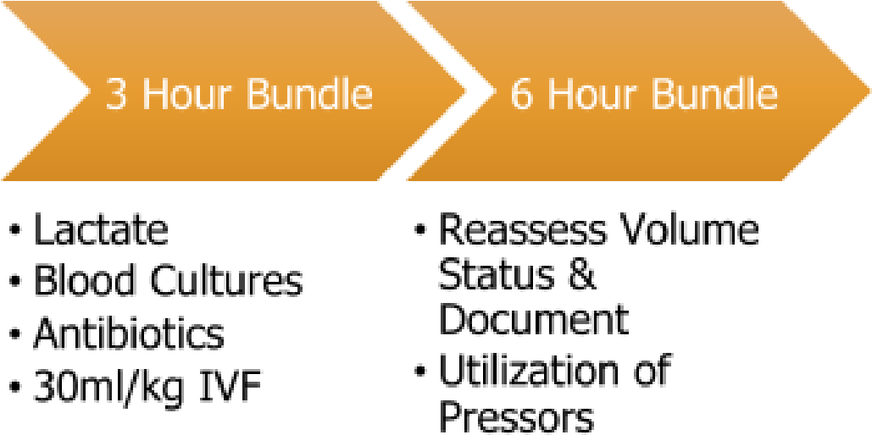
Patients who trigger SIRS criteria will be flagged with a red “Sunburst” on the tracking board. This alone does not require any action, however, when you see a “Sepsis Sun” you should immediately evaluate that patient for the potential for sepsis. Every ER is required to meet certain time standards for septic patients. Keep in mind, the clock starts when the patient presents, not when you recognize the patient as SIRS. If you choose not to treat a patient as possible sepsis, ensure you document why.
Patient Expectations
Our patients come with a broad range of medical knowledge and access to care. Their expectations for
the visit will probably differ than your plan for their stay. When initially seeing your patients, determining their expectations, and setting realistic possibilities, will help streamline their care and prevent headaches when the time comes for disposition decision making. This is especially important when discussing the use of narcotic pain medications; along with the rest of the care team, set a unified plan for pain control, and stick to your plan. There are ​new CDC guidelines​ you can reference for further information. Most patient frustrations surround understanding the plan of care, dealing with delays, and
feeling that their concerns have been understood and addressed. ​Always return and talk to your patient before they are discharged.

Golden Rules of the ER
Never sign out procedures.
Pelvic exams, rectal exams, wound care, etc. should not be signed out to the oncoming resident.
Always document EKGs
Notes with undocumented EKGs are pushed back to you later, so make sure you document EKGs (labs, orders, etc are also required).
Provide Safe Care
Speed is not the answer. Your first goal is to provide safe, quality care. Efficiency will come with practice. If you feel overwhelmed let your senior know.
Respect & Protect your nurses and staff
Our nurses and staff are our part of our family and team. If they have concerns about a patient, lab, medication or plan, please take careful consideration of their request. Additionally, the ER is unfortunately a place prone to aggression towards staff. Please alert security if you have any concern for the safety of yourself, our staff, or our patients.

Questions?
If you have any questions or concerns, please feel free to reach out to our chief residents, or call the backup chief (on your emailed schedule). You can also reach out to any of our residents, faculty, or staff during your shifts. Have a great month!

